The “INSERT()” MYSQL function is used to place a string inside of another string. This function is useful for changing the name of a certain string in your database.

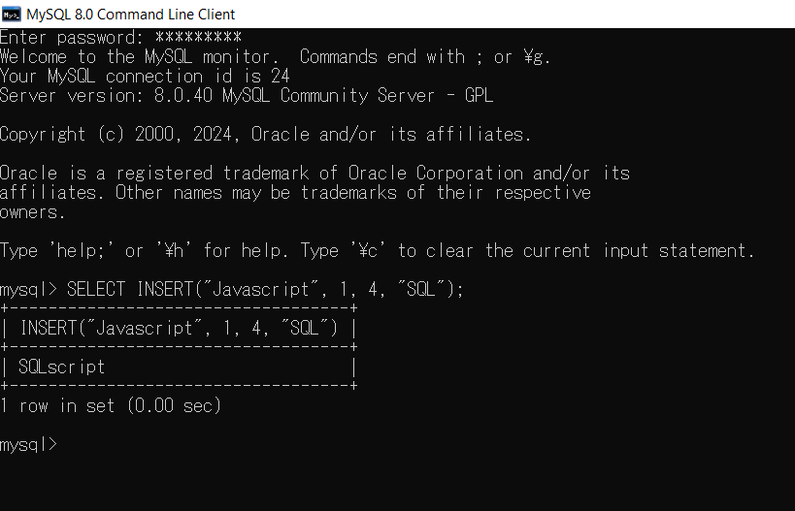

The “LOCATE()” function is used to find the position of the first instance of a substring in a string. This function is good for quickly finding a specific name among a set of records.

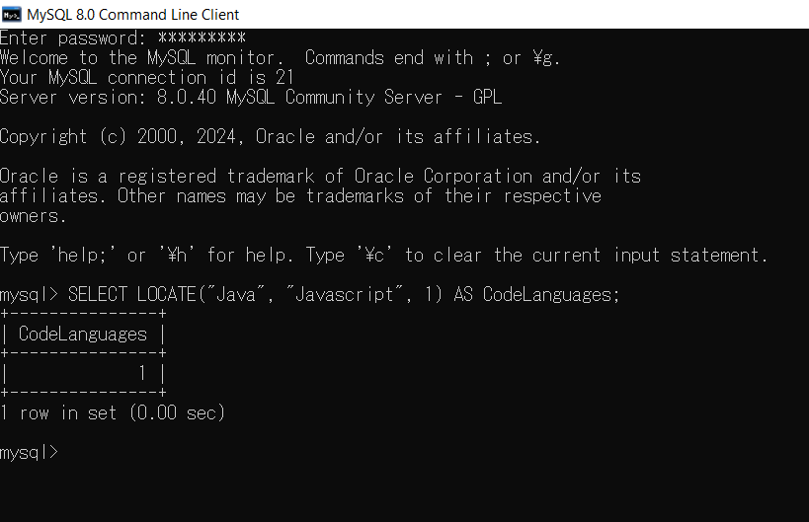

The “STRCMP()” function is used to directly compare two strings to one another. This function will help you in a case where two items in your tables share the same name and need to be distinguished from each other.
